To create a new SQL Job, follow the steps below

Login in to SQL studio as shown below

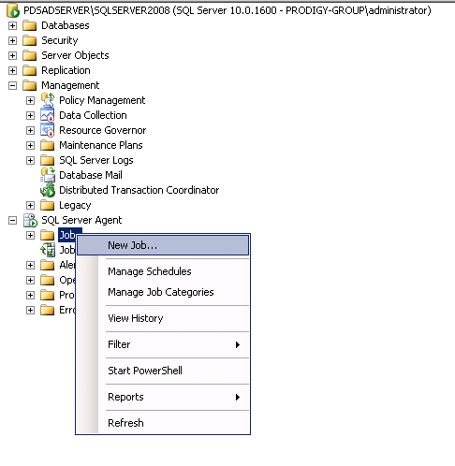

Right click on Jobs and choose New Job as shown above

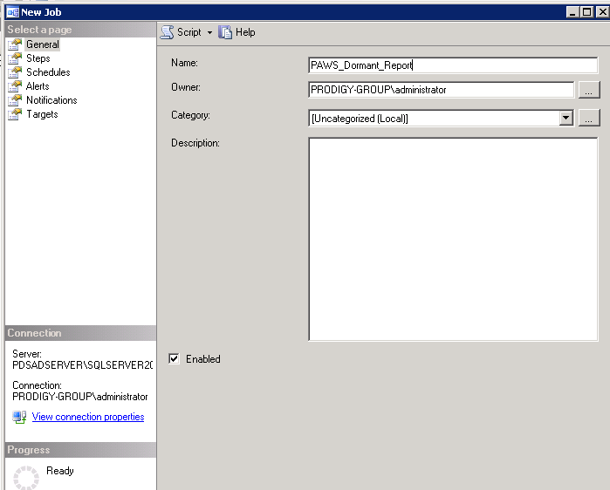

Give a name to “Job” and click on Steps as shown below

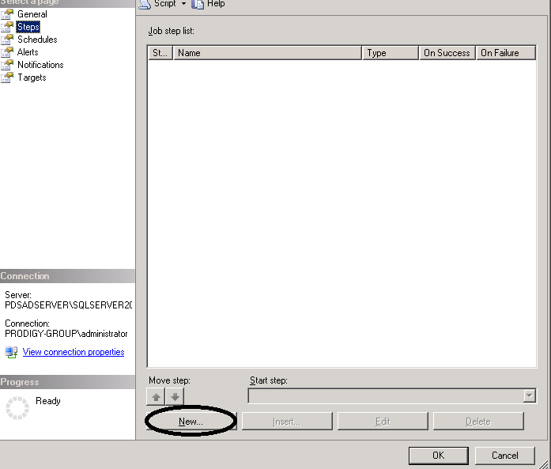

Click on **New** as shown above

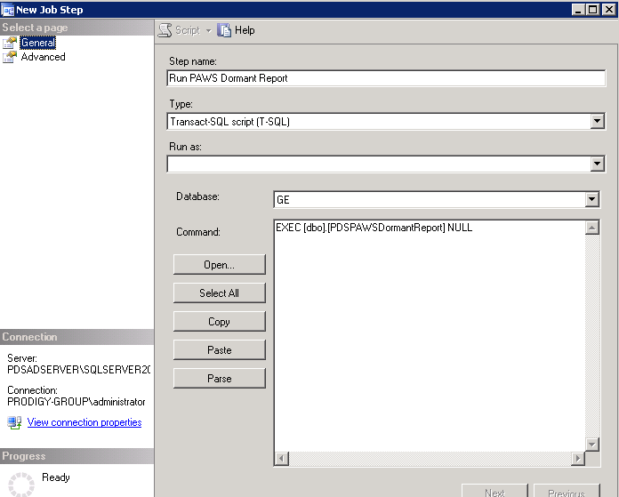

Give a name to the step and enter the following query into Command as shown above

EXEC [dbo].[PDSPAWSDormantReport] 'NULL'

Click Next to save the step

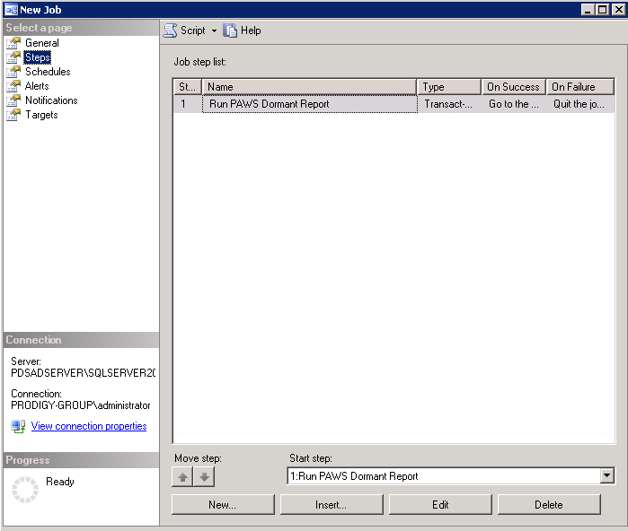

Click on schedule as shown below

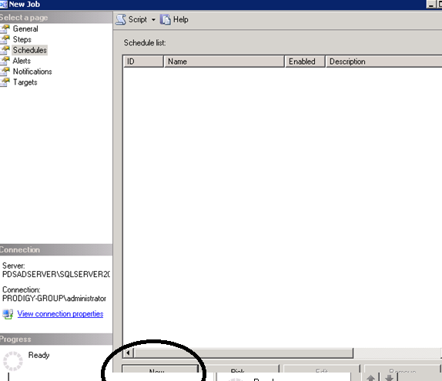

Click New to create a new schedule as shown above

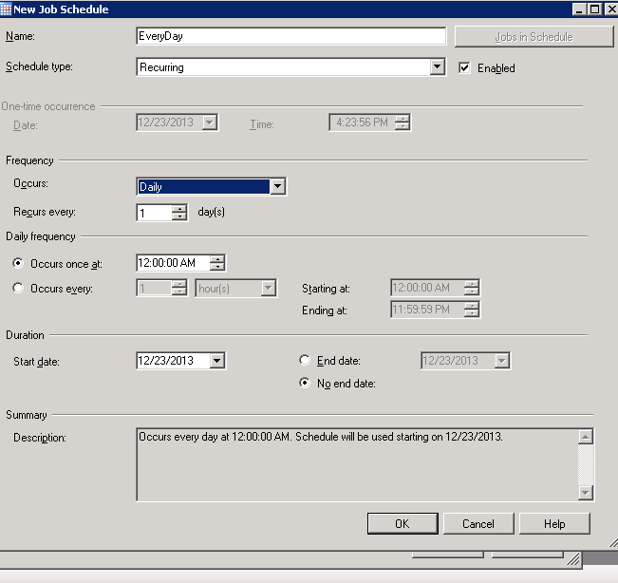

Input the scheduling details as shown above and click OK

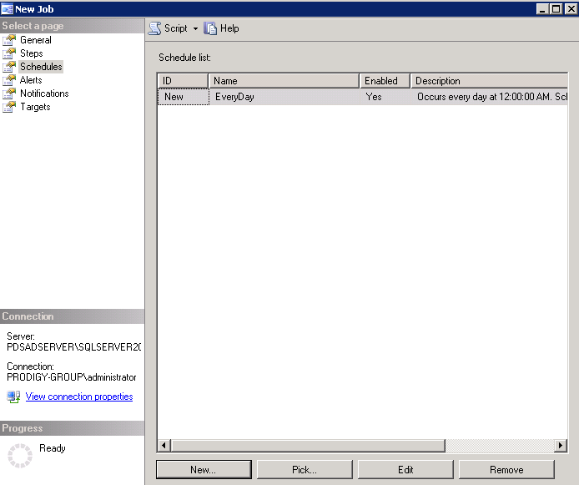

After that, you can click ok to save the job



